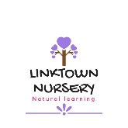
Linktown Nursery – Improvement Plan 2020-2021
What do we want to achieve? | How will we achieve it? | How will we know? | Time
Expansion to our outdoor area to further develop opportunities for taking learning outside | - Old ramp to be replaced and new one built. Eating area with shelter to be added.  - Resources added to ensure learning opportunities are at the heart of curriculum delivery  - Planned activities suitable each age and ability  - Staff and families to work together to identify areas and how best to use them when supporting children.  - Focus on Literacy and Maths in the outdoors, and how we can incorporate this into our setting | - Feedback from outside agencies and families.  - Observations  - Planning and assessment  - Continuing professional development | By Dec 2020
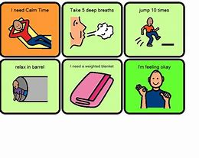  Staff knowledge of effective communication and challenging behaviour | - Work to support those identified children helping them to develop emotional well-being and greater involvement in their play, accessing outside agencies if appropriate.  - Use observation to identify and patterns of behaviour so that strategies can be put in place to support daily transitions  - Open communication and building partnerships with families  - Monitor to identify triggers and how to support this  - On-line training and assessment on behaviour management technique  - Support and supervision  - Team meetings | - Feedback from outside agencies and families.  - Observations  - Planning and assessment  - Continuing professional development  - Personal learning journals  - Reports and trackers | By April 2021
Knowledge in health & wellbeing, adverse childhood experiences and emotional support in the Early Years | - Bespoke training and webinars  - Staff knowledge on how to promote mindfulness in early years setting  - Adding mindfulness activities into planning  - Enhance knowledge on ACE’s mental and physical changes  - Adopt & support family friendly policies as an employer  - Enhance connection to families & recognise their challenges  - Support community programmes  - Liaise with local authority | - Feedback from outside agencies and families.  - Observations  - Planning and assessment  - Continuing professional development  - Personal learning journals  - Reports and trackers | Aug 2021

